**PROJECT DEVELOPMENT PHASE**

**SPRINT - 4**

|  |  |
| --- | --- |
| DATE | 17 NOVEMBER 2022 |
| TEAM ID | PNT2022TMID11845 |
| PROJECT NAME | SMART FASHION RECOMMENDER APPLICATION |

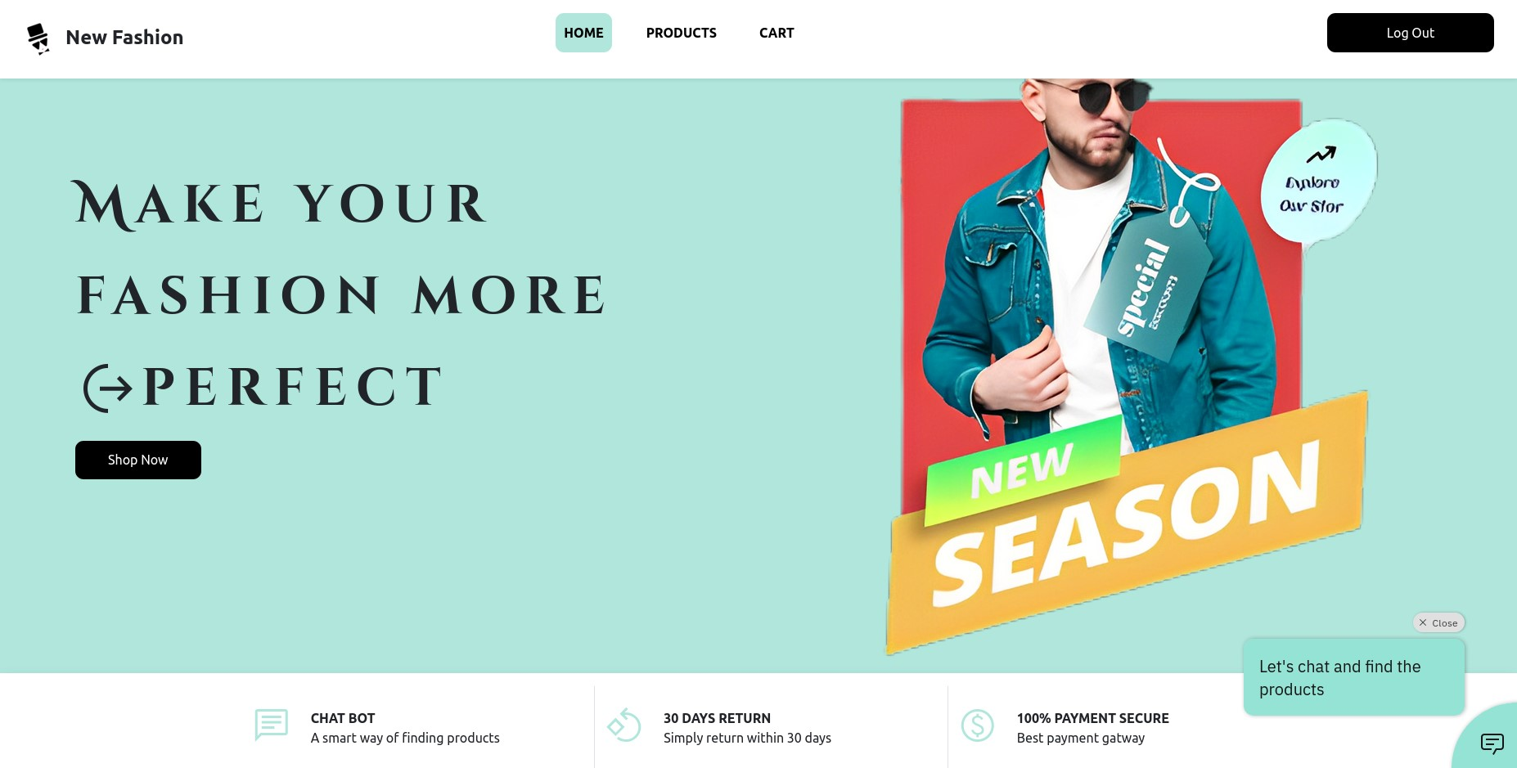**CHATBOT INTEGRATION**

|  |
| --- |
| let body = <HTMLDivElement> document.body; window.watsonAssistantChatOptions = { |
| integrationID: "491873b3-90fe-47a0-867b-484cc805a0b4", // The ID |
| of this integration. |
| region: "au-syd", // The region your integration is hosted in. |
| serviceInstanceID: "65396cc7-c978-42a3-8def-8644b440581d", // |
| The ID of your service instance. |
| onLoad: function (instance: { render: () => void; }) {  instance.render(); } |
| }; |
| setTimeout(function () { |
| const t = document.createElement('script'); |
| t.src = |
| "https://web-chat.global.assistant.watson.appdomain.cloud/versions/" + |
| (window.watsonAssistantChatOptions.clientVersion || 'latest') +  "/WatsonAssistantChatEntry.js"; |
| body.appendChild(t); |
| }); |

**CHATBOT UI DESIGNS**

**MAIN CHATBOT OPEN SCREEN**

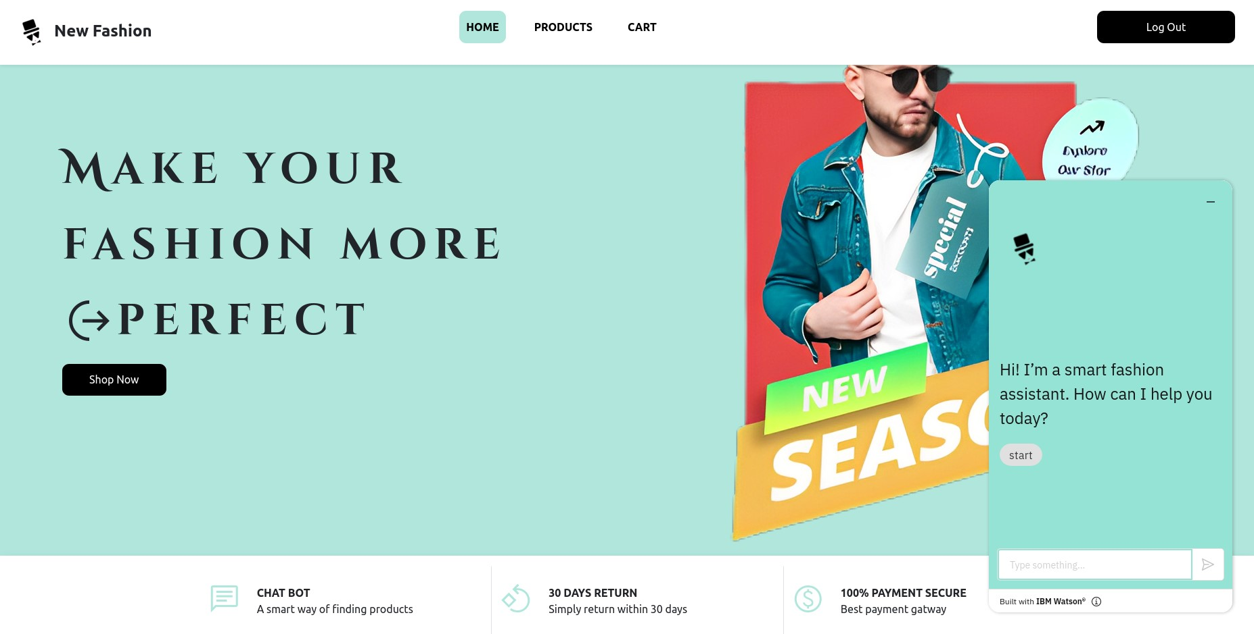

**CHAT SCREEN**

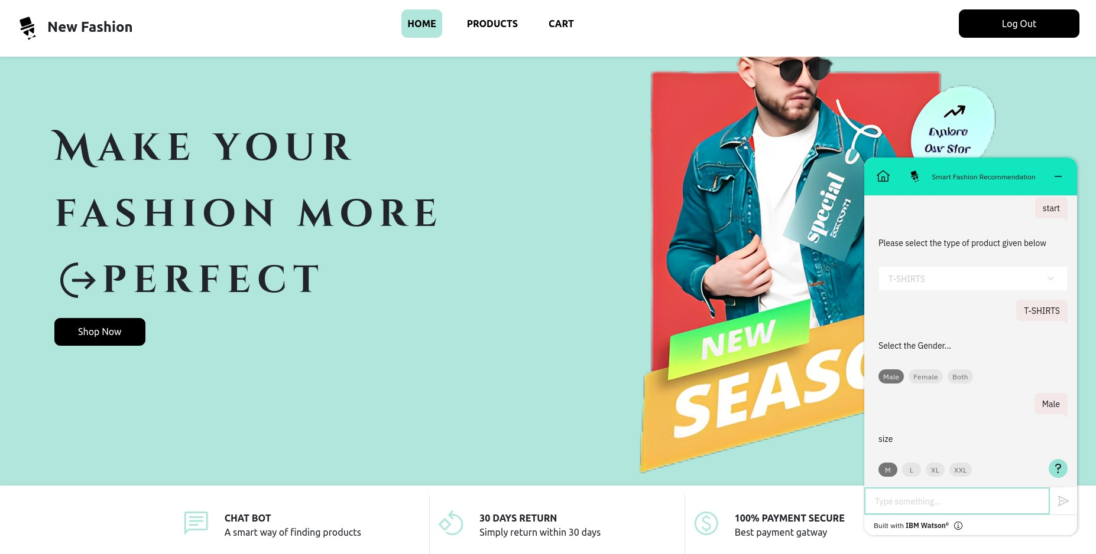

**FINDING PRODUCTS USING CHATBOT**

